Evolution of Visualization

Michael Surdek

Southern New Hampshire University

The visualizations I reviewed from SAS Visual Analytics are:

* Banking & Risk Insights
* Network Performance
* Retail Insights
* Warranty Analysis
* World Happiness Analysis

The visualizations I reviewed from Tableau Public Gallery are:

* Google’s 2020 Year in Search
* USWNT World Cup Goals
* 20 Years Of Grand Slam Championships
* Disney+
* Economic Output in US Counties

Both resources provided detailed and engaging visualizations for a variety of topics. The topics shown in the SAS gallery seemed to be more generic tools with default data that could be used for specific industries or companies. The Tableau gallery contained more unique topics that were of interest to the creator and were designed in collaboration with the data itself to effectively display the information.

Most of the demos from the SAS gallery contained multiple tabs and multiple visualizations on each tab. Each tab had a description that explained the information that was being displayed. These visualizations were also interactive in that there was usually a drop down or toggle menu that allowed the user to select what data should be shown on the corresponding visualizations. Some of the charts themselves allowed the user to click on a certain aspect that would alter the rest of the visualizations accordingly. The Automated Explanation tab of the Retail Analysis demo contained a feature that showed how sales were related to other variables, and I could click on each variable to see how the relationships changed. It also displayed and highlighted significant statistics that could be uncovered in individual factors of the retail analysis. This was a helpful tool that allowed me to explore different angles of the data to get a better understanding overall.

The demos from the Tableau gallery all contained exactly one visualization. They were less interactive, but it was still always possible to toggle over the visualization to receive more information about particular data points. I noticed that the Tableau visualizations did a great job of using the layout and color schemes in parallel to the overall message of the data. For example, the Google demo used the colors from the Google logo, and the USWNT demo used mostly red, white, and blue. With these demos, there was less space to interact with the data on my own, but the purpose seemed to be more along the lines of simply displaying one individual overall message, rather than providing a platform for the user to discover their own insights.

One visual from the SAS gallery that I found effective is the “Cell Towers The Customer Has Used” chart from the Customer’s Speed tab of the Network Performance report. The visual was a map that showed circles representing individual cell towers that an individual was connected to over a certain time period. The circles varied in size (data size) and color (data speed). I was not able to derive many insights from the visual of one individual, other than it looks like they traveled down a highway from the Dallas area to the Abilene area. However, this type of visualization seems like it could be very effective to detect abnormalities among cell towers or to provide information about which cell towers need to be upgraded to handle larger capacities.

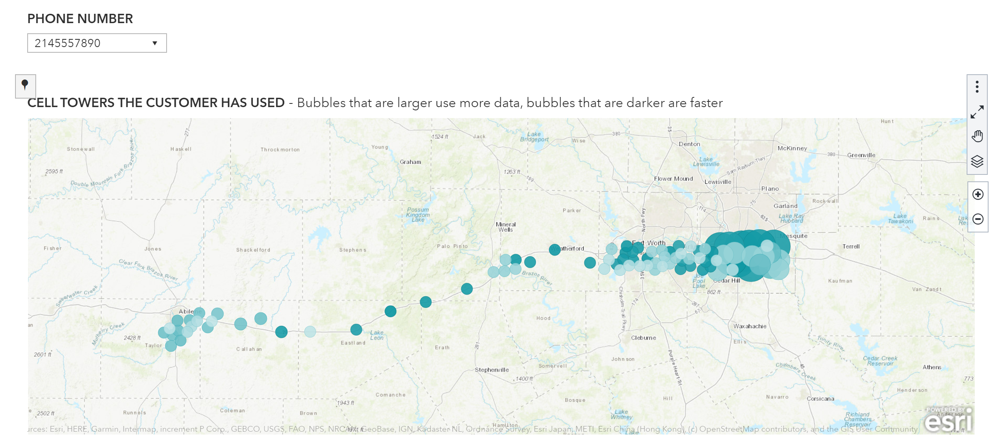

One visual from the Tableau gallery that I found effective is the scatterplot on the Disney+ demo. The visual showed a clear trend of decreasing Imdb ratings for more recent release years. The demo also included a more simplified trend line of Imdb ratings compared to the number of films released in a given year. This was a helpful addition to the visualization. The visual also used the colors of the points on the scatterplot to display each film’s genre, and it showed the average rating for each genre, which added more useful information.

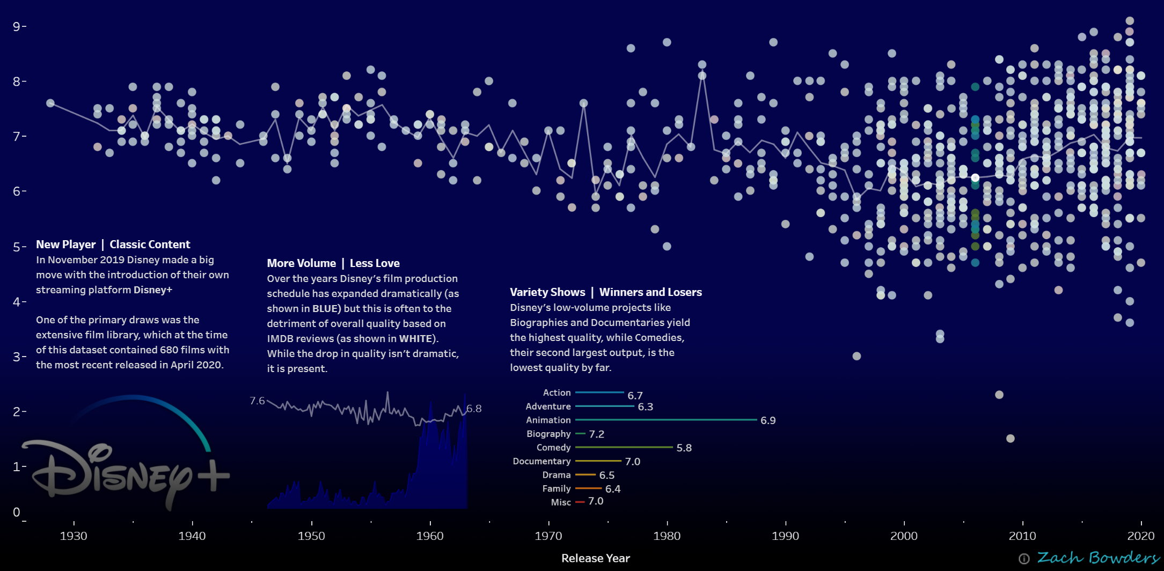

One visual from the SAS gallery that I found confusing is the Gross Labor Amount by Repairing Dealer chart from the Labor Details tab of the Warranty Analysis demo. The chart is a scatterplot with Gross Labor Amount in $ on the y-axis and each individual repairing dealer takes up a spot on the x-axis, ranging from D000 to D999. At first, I was confused about what the different points represented because the x-axis is not labeled, but by scrolling over the individual points, I noticed that each point is one repairing dealer. I think this chart could be good at identifying outliers, such as the points near the top of the chart. However, a scatterplot might not have been the optimal choice for this visualization because there is seemingly no relationship between the Gross Labor Amount and the number from 0 to 999 that each repairer was assigned.

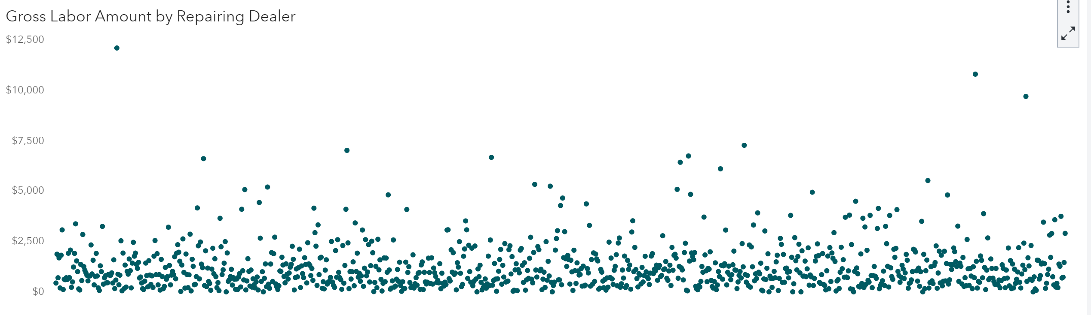

One visual from the Tableau gallery that I found confusing is the 20 Years of Grand Slam Championships. The creator choose to use two sets of points representing players and individual championships connected by curved lines of various colors for Nadal, Federer, and Djokovic. Due to these choices, I was easily able to understand the creator’s main point that those three tennis players have won almost all of the recent championships. However, the remaining players were not labeled, and I am not sure if there was any rhyme or reason for where the players were located or how the curves were drawn. If it were my visual, I probably would have ordered the players at the bottom starting with the one who one their first championship at the earliest time and then so on.

